***Genealogical data form  
Kwartierstaat / Pedigree chart***

Collect genealogical data from your own family circle about living and / or deceased relatives up to approximately three generations ago. Sometimes a marriage certificate, family printing or questioning other family members can provide some solution. Provide this information as completely as possible for the purpose of the research. The fields ‘Occupation’ and ‘Additional information’ are not mandatory. The form below has been made available to you, but you can also send the data by e-mail. Another form is available on the website for the submission of photo material. All data that you provide will only be used for the research and will never be provided to third parties. In short: the privacy law is carefully observed.

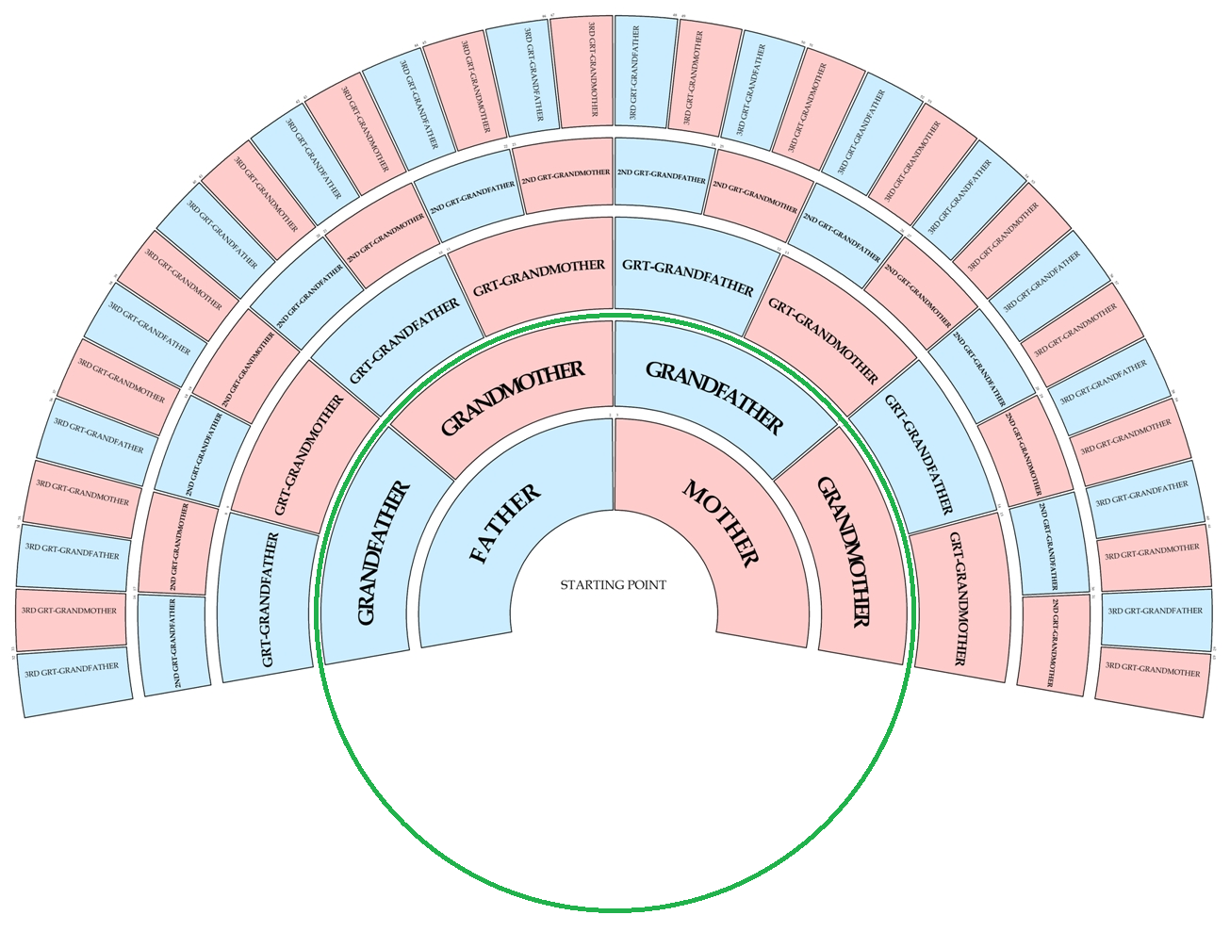

**Starting point (with option to add brothers and/or sisters)**

|  |  |  |  |
| --- | --- | --- | --- |
| Last name |  | | |
| Given names |  | Nickname |  |
| Place and date of birth |  | | |
| Occupation (not required) |  | | |
| Additional information  (not required) |  | | |

|  |  |  |  |
| --- | --- | --- | --- |
| Last name |  | | |
| Given names |  | Nickname |  |
| Place and date of birth |  | | |
| Occupation (not required) |  | | |
| Additional information  (not required) |  | | |

|  |  |  |  |
| --- | --- | --- | --- |
| Last name |  | | |
| Given names |  | Nickname |  |
| Place and date of birth |  | | |
| Occupation (not required) |  | | |
| Additional information  (not required) |  | | |

|  |  |  |  |
| --- | --- | --- | --- |
| Last name |  | | |
| Given names |  | Nickname |  |
| Place and date of birth |  | | |
| Occupation (not required) |  | | |
| Additional information  (not required) |  | | |

|  |  |  |  |
| --- | --- | --- | --- |
| Last name |  | | |
| Given names |  | Nickname |  |
| Place and date of birth |  | | |
| Occupation (not required) |  | | |
| Additional information  (not required) |  | | |

**Father**

|  |  |  |  |
| --- | --- | --- | --- |
| Last name |  | | |
| Given names |  | Nickname |  |
| Place and date of birth |  | | |
| Place and date of death |  | | |
| Place and date of marriage |  | | |
| Occupation (not required) |  | | |
| Additional information  (not required) |  | | |

**Mother**

|  |  |  |  |
| --- | --- | --- | --- |
| Last name |  | | |
| Given names |  | Nickname |  |
| Place and date of birth |  | | |
| Place and date of death |  | | |
| Occupation (not required) |  | | |
| Additional information  (not required) |  | | |

# 

# 

**Grandfather (fathers side)**

|  |  |  |  |
| --- | --- | --- | --- |
| Last name |  | | |
| Given names |  | Nickname |  |
| Place and date of birth |  | | |
| Place and date of death |  | | |
| Place and date of marriage |  | | |
| Occupation (not required) |  | | |
| Additional information  (not required) |  | | |

**Grandmother (fathers side)**

|  |  |  |  |
| --- | --- | --- | --- |
| Last name |  | | |
| Given names |  | Nickname |  |
| Place and date of birth |  | | |
| Place and date of death |  | | |
| Occupation (not required) |  | | |
| Additional information  (not required) |  | | |

**Grandfather (mother’s side)**

|  |  |  |  |
| --- | --- | --- | --- |
| Last name |  | | |
| Given names |  | Nickname |  |
| Place and date of birth |  | | |
| Place and date of death |  | | |
| Place and date of marriage |  | | |
| Occupation (not required) |  | | |
| Additional information  (not required) |  | | |

**Grandmother (mother’s side)**

|  |  |  |  |
| --- | --- | --- | --- |
| Last name |  | | |
| Given names |  | Nickname |  |
| Place and date of birth |  | | |
| Place and date of death |  | | |
| Occupation (not required) |  | | |
| Additional information  (not required) |  | | |